**Homework Wan Huzaifah bin Wan Azhar**

**Answer:**



* As address space grows, the page table size must eventually grows to fit the page into the page table.
* From the example, 1m of address is mapped to 1k of page but 2m of address must be mapped to 2k of pages.
* As page size grows, the address space can accommodate the page more. As such, the number of pages in the page table decrease.
* For example, if there is a 1m address space and 1k page table size. Each byte of page in page table is mapped to 1 kb of address space. So, if there is 4k page table size. 1m of address space is can be divided into 4, so that the total size of page table is 256 (1 VPN refers to 4 kb of address space)



* The address space size is 16k. 16k = 16384 b.
* 2^14 = 16384.
* Therefore, there is 14 bits of address.
* 4 bits from 14 is to be the page number while the rest is offset because the page table size is 16 and 4 bits can form 16.

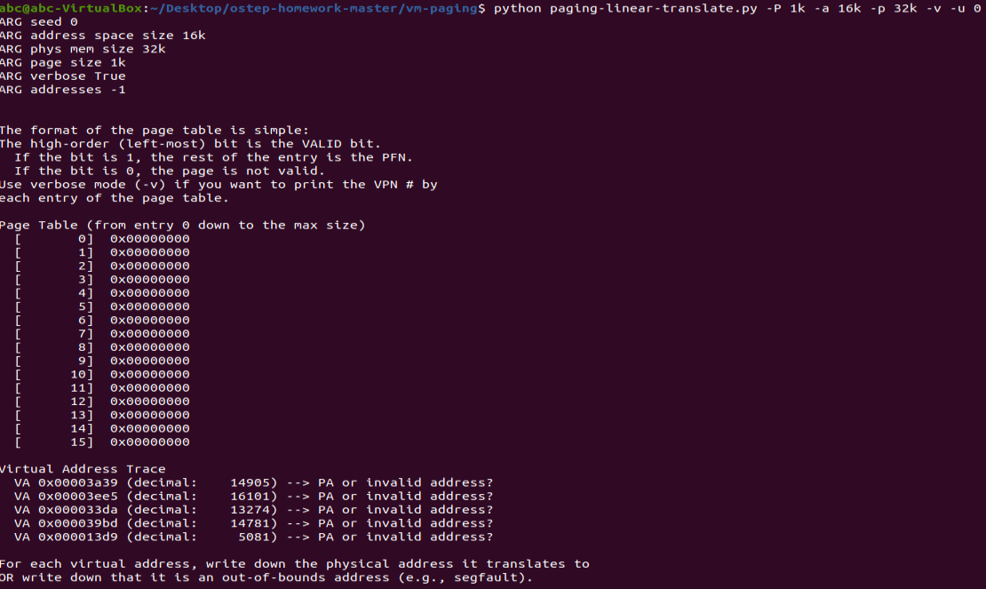

* 14905 -- > VPN14 is not valid
* 16101 -- > VPN15 is not valid
* 13274 -- > VPN12 is not valid
* 14781 -- > VPN14 is not valid
* 5081 -- > VPN4 is not valid

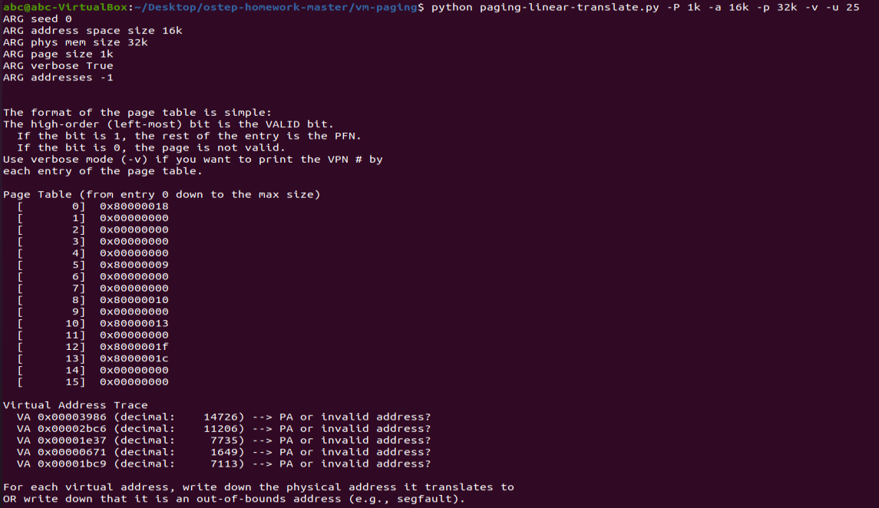

* 14726 -- > VPN14 is not valid
* 11206 -- > 0x00004FC6 (decimal 20422) VPN10 is valid
* 7735 -- > VPN7 is not valid
* 1649 -- > VPN1 is not valid
* 7113 -- > VPN6 is not valid

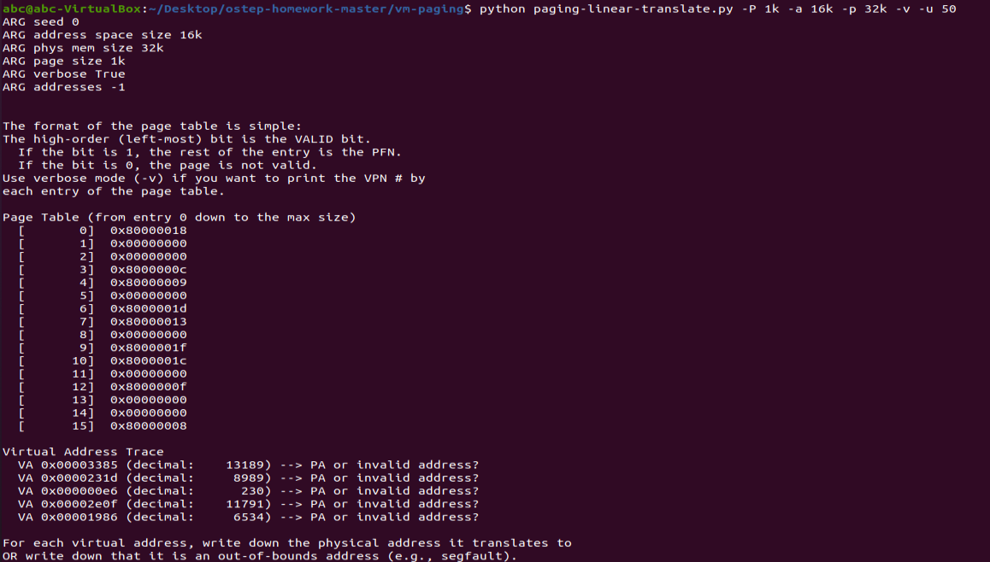

* 13189 -- > 0x00003F85 - VPN12 is valid
* 8989 -- > VPN8 is not valid
* 230 -- > 0x60E6 - VPN0 is valid
* 11791 -- > VPN11 is not valid
* 6534 -- > 0x00007586 - VPN6 is valid

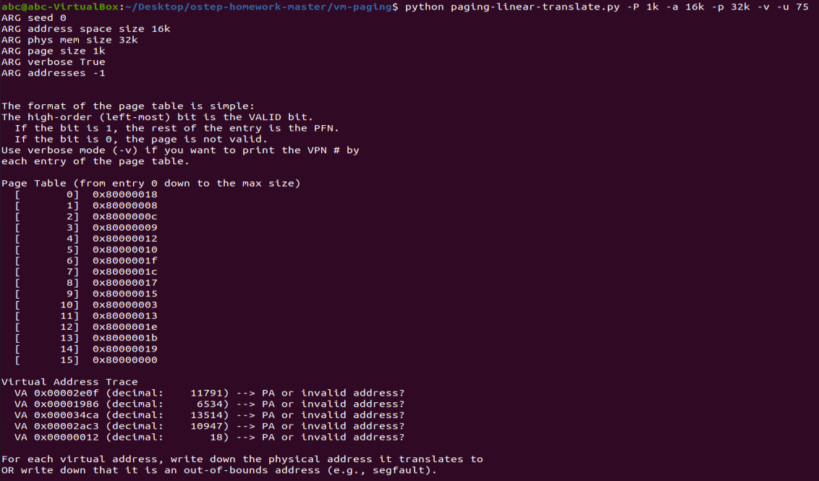

* 11791 -- > 0x00004E0F – VPN11 is valid
* 6534 -- > 0x00007D86 – VPN6 is valid
* 13514 -- > 0x00006CCA – VPN13 is valid
* 10947 -- > 0x00000EC3 – VPN10 is valid
* 18 -- > 0x00006012 -- VPN0 is valid

If the percentage of allocated page increase, the number of valid virtual address increase



* “paging-linear-translate.py -P 1m -a 256m -p 512m -v -s 3” is unrealistic
* This is because for 256m address space, the page size is 1m, therefore the page table size is big.
* The page size is too big for the physical address. At this parameter, only two programs can run at one time.



* If address-space size is bigger than physical memory, then it doesn’t make sense and the script will break.
* It does not make sense because there is no reason an address space for one program should exceed physical memory.